962 - Design Document – Transfer Document

# Transfer Document

Valley

12/31/2014

Reviewed by: Mechelle Mounts, , Kathy McCall, Justin Hyatt, and AFIA

Version 3.1

Note: The purpose of the Design Document is to be used to outline a process within the SmartCare system. This includes screen shots of all applicable pages, as well as how set up is needed for each page to function. It also includes any global codes, jobs, rules, scripts, initializations, or validations used to set up these pages.

## Summary

Valley is requesting to use the Ionia version of the transfer document with no functionality or UI changes.

### *Purpose*

The Transfer Document is a tool used by clinicians within the SmartCare system to request changes in the client’s current program enrollment.

## System Design

Valley will use Transfer document “As Is” with no system changes per the MI Demo Environment

### *Transfer Document Screen*

1. Add hover help to the “reason/assessed need” field stating “Include risk factors, anticipated problems and barriers to treatment. List goal expectation for this referral” –*client to add post development delivery*

#### Requirements

|  |  |  |  |  |
| --- | --- | --- | --- | --- |
| Field | Required | Response Options | Validation Message | Document Creation Initialization |
| Request Date | Yes | Via calendar date selection | Transfer Document-General- Request Date is required | None |
| Status | Yes | Via dropdown selection   * Not Sent * Sent | Transfer Document-General- Status is required | * When initial document is being created status =Not sent * When in progress is opened status =Sent |
| From Staff | Yes | Via staff list dropdown | Transfer Document-General- From Staff is required | Via logged in staff |
| Reason/Assessed Need For Transfer | Yes | Via textbox | Transfer Document-General- Reason/Assessed Need For Transfer is required | None |
| Receiving Staff | Yes | Via staff list dropdown | Transfer Document-General- Receiving Staff is required | None |
| Rec. Programing | Yes | Via program list dropdown | Transfer Document-General- Rec. Programing is required | None |
| Service | No | Via dropdown selection   * Active procedure codes | None | None |
| Client Has Participated And Is In Agreement With This Transfer | No | Via checkbox | None | None |
| Comments | No | Via checkbox | None | None |
| Receiving Action | Yes | Via dropdown selection   * Accept * Forward * Reject | Transfer Document-General- Receiving action is required | None |

#### Rules

|  |  |  |  |
| --- | --- | --- | --- |
| Field | Rules | Validation Message | Initializations Occurring on Signature |
| Entire Document | None | None | * On sign-creates an in progress document for the “receiving staff” listed on document (shows up in documents widget) * Sends an alert to the “receiving staff” listed and shows up on their alert widget in dash board. (see screen shot below) |

### User Interface Screen Shot

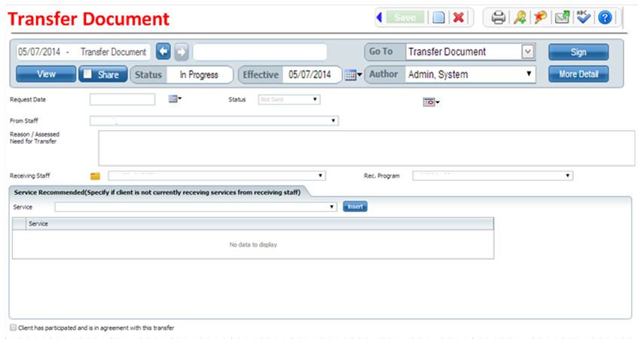



Alert

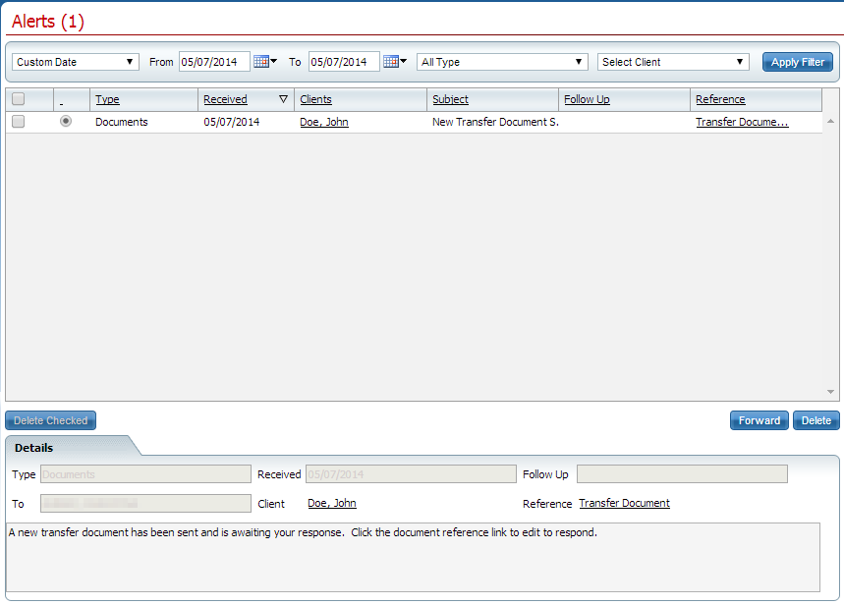

Is this procedure a notification screen only, or is there logic built behind the receiving action.

For example, if accepted, is the sending staff notified? DR: Please add this to the Alert list

Is the client enrolled in the new program? DR: if the transfer is accepted then the client is automatically enrolled into the new program.

What does forward do? DR: The Forward button is to allow the users to forward an alert.

What notifications happen with reject? DR: Please add this to the Alert list.

Are there any notifications for the sending person? DR: Notifications are based on the alerts specified above.

Are these kept historically? DR: all transfer documents and alerts are kept historically.